# How to Setup Jenkins in Docker Container?

we will look into the process of setting up **Jenkins** in a **Docker** container on an **EC2** instance.

* **Jenkins**is an open-source automation server that is used to automate different parts of your software development related to building, testing, and deploying.
* **Docker** is a set of platforms as a service product that uses OS-level virtualization to deliver software in packages called **containers.**
* **EC2** or**Elastic Compute Cloud** is a scalable computing service launched on the AWS cloud platform.

Now, let’s look step-by-step process for this setup.

**Implementation:**

**Step 1:**First, log in to your [AWS](https://aws.amazon.com/console/) account and go to the EC2 service. There launch any free tier **Amazon Linux** machine. Here is the image attached to refer to.

Make sure your Security inbound rules look like this. So that you don’t have any further issues.

**Step 2:**After launching, SSH to that EC2 instance. And

Install Docker by running the following commands.

sudo yum update -y

sudo yum install docker

sudo service docker start

sudo service docker status

sudo systemctl enable docker

# To add ec2-user to docker group

sudo usermod -a -G docker ec2-user

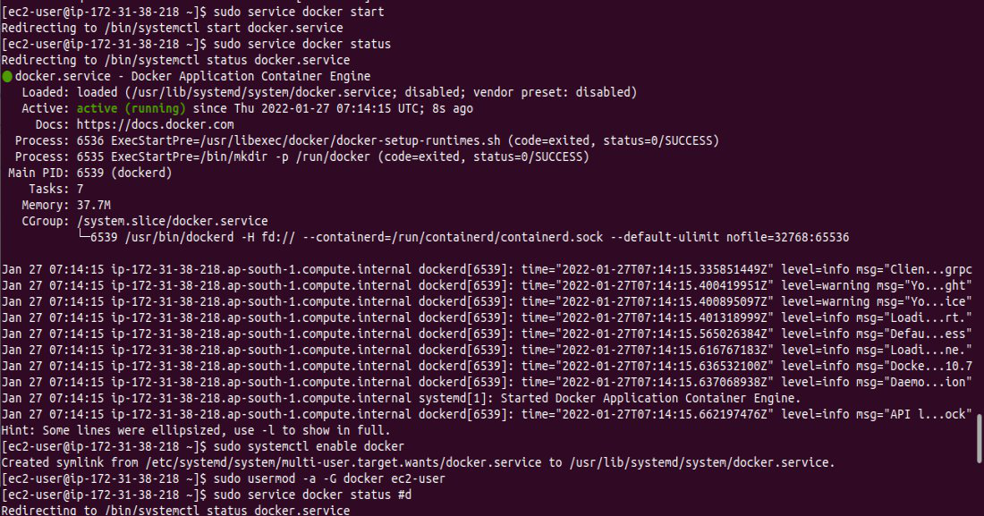

Now, to check if docker is installed or not. Run below command and match with an image attached further.

docker -v # It will give you docker version



**Step 3:**Now we will pull the **Jenkins** image using docker from the docker hub.

Run the below command :

docker pull jenkins/jenkins # To pull the image of jenkins

docker images # To see if image is downloaded or not

**Step 4:**Since in docker images we can see our **Jenkins** image. Now we can make our Jenkins container. But before that make a directory.

Run below command

mkdir jenkins #To make directory name jenkins

After making this directory run the below command

docker run -d --name jenkins -p 8080:8080 -v $PWD/jenkins/ jenkins/jenkins

docker ps # To see if container is running or not

Now, copy the **Public IPv4 address** of the **EC2** instance. Refer to the below image for any confusion.

After copying it. Paste it into a new tab and write it with port 8080. Refer the below image for better understanding and resolving confusion.

After running this, you’ll see a screen like this.

**Step 5:**To get this **password.**Run the below command in the EC2 instance and copy the password. Refer to the image if there is any confusion.

docker logs jenkins

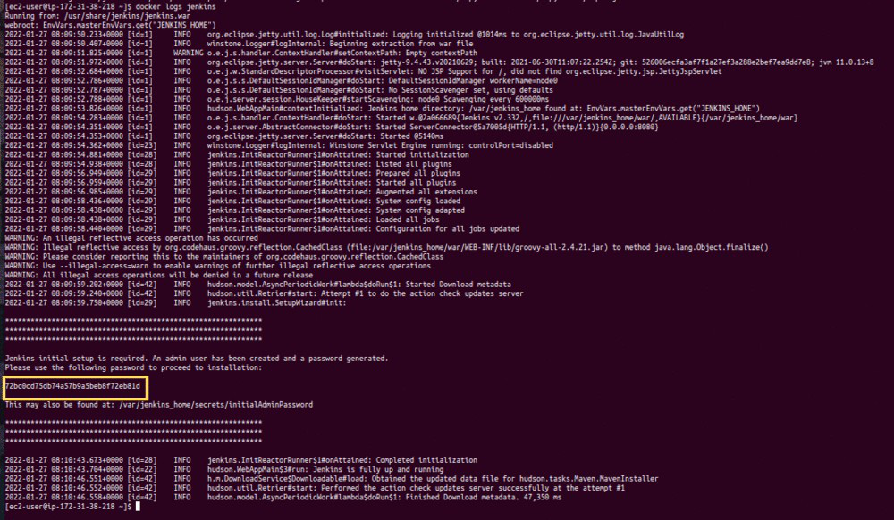

After entering this password, Install all the plugins (it may take a while).

**Step 6:**Once all the plugins are installed you’ll be asked to make a user with a password and After making that user. You’ll be logged into Jenkins.

**Congratulations!**If you have come this far that’s mean you have successfully set up the **Jenkins** in **Docker** container. Now you can easily automate your software using **Jenkins**.